Naïve comparison of the MAVORIC trial and ALCANZA trial progression-free survival curves

Figure 1: Kaplan–Meier investigator-assessed progression-free survival curves for observed vorinostat (MAVORIC trial - ITT) versus physician’s choice (ALCANZA trial - ITT) – 2016 data cut
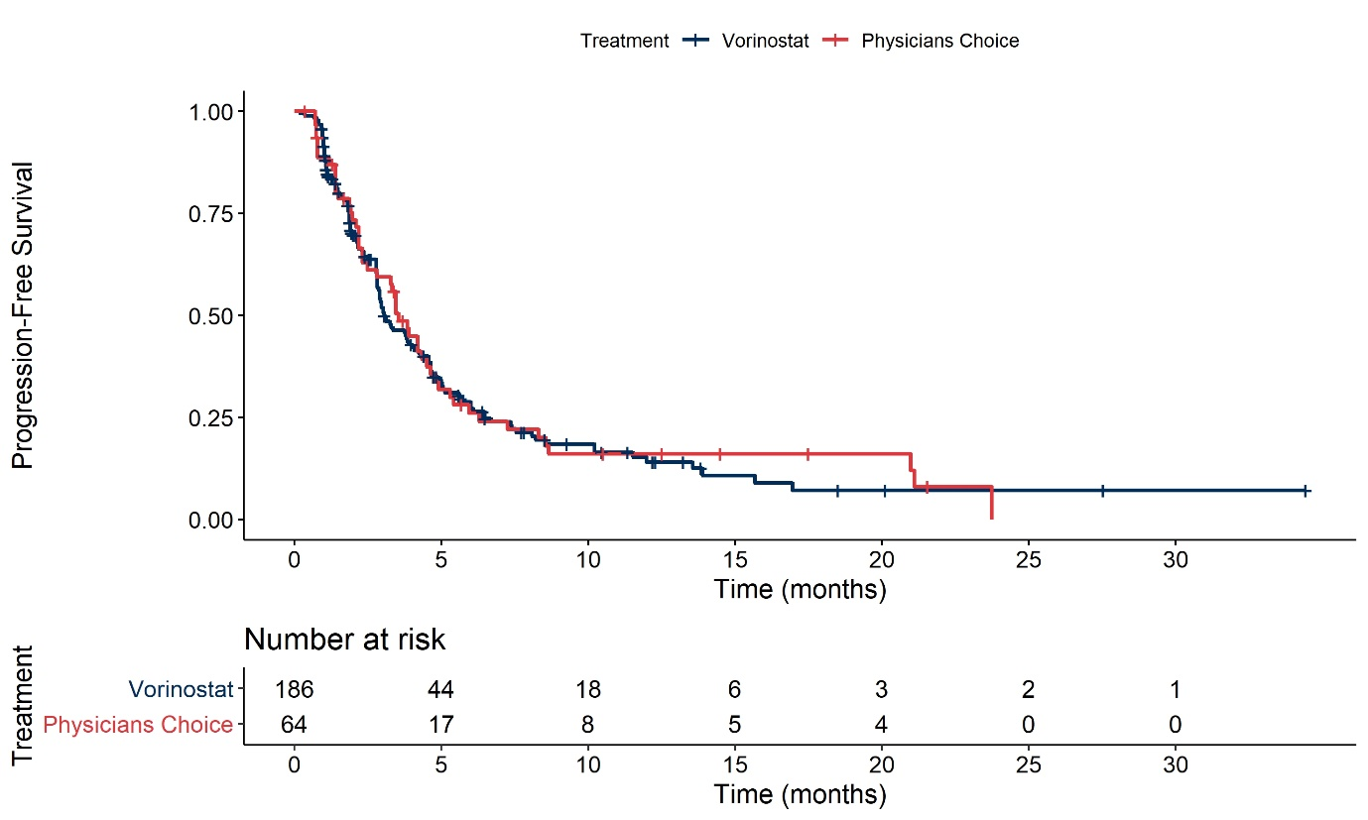
Abbreviations: ITT, intention-to-treat.

Survival analysis for overall survival (OS)

Figure 1: Diagnostic plots for re-weighted MAVORIC trial OS - 3rd line advanced MF and 2nd line SS population
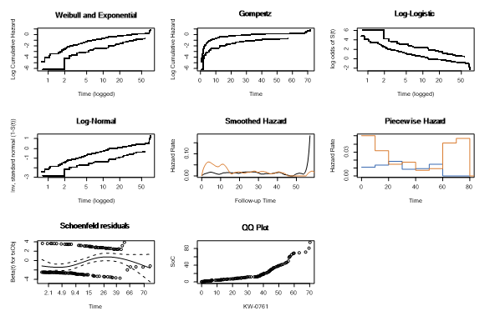
Abbreviations: OS, overall survival; MF, mycosis fungoides; SS, Sezary syndrome

Table 1: AIC and BIC statistics OS – 3rd line advanced MF and 2nd line SS population
Model | AIC HES | BIC HES | AIC Mogamulizumab | BIC Mogamulizumab
Exponential | 690.50 | 693.30 | 339.20 | 342.20
Generalised Gamma | 668.90 | 677.40 | 341.50 | 350.30
Gompertz | 680.30 | 685.90 | 340.90 | 346.80
Log-logistic | 676.80 | 682.50 | 340.40 | 346.30
Log-normal | 671.80 | 677.50 | 339.60 | 345.40
Weibull | 685.20 | 690.90 | 341.20 | 347.10
Abbreviations: AIC: Akaike Information Criterion, BIC: Bayesian Information Criterion; MF, mycosis fungoides; SS, Sezary syndrome; OS, overall survival; HES, Hospital Episode Statistics.

Figure 2: Comparison of OS extrapolations between re-weighted MAVORIC mogamulizumab arm and HES data, 3rd line advanced MF and 2nd line SS population
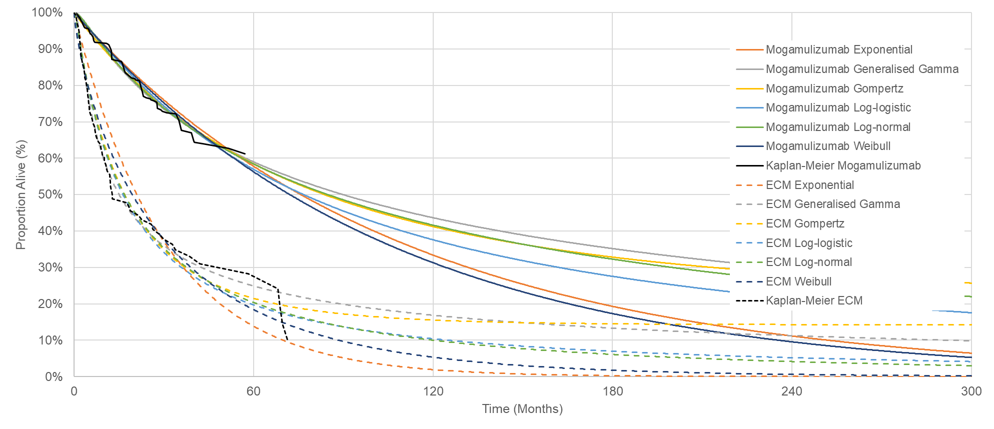
Abbreviations: ECM, established clinical management; OS, overall survival; HES, Hospital Episode Statistic; mycosis fungoides; SS, Sezary syndrome

Survival analysis for next-treatment-free survival (NTFS)

Figure 6: Diagnostic plots for re-weighted MAVORIC trial NTFS, 3rd line advanced MF and 2nd line SS population
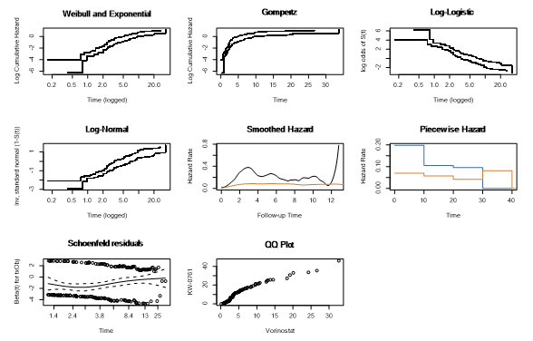
Abbreviations: NTFS, next-treatment-free survival; MF, mycosis fungoides; SS, Sezary syndrome

Table 2: AIC and BIC statistics for parametric survival model fits to NTFS Kaplan-Meier data, 3rd line advanced MF and 2nd line SS population
Model | AIC V | AIC M | Joint | BIC V | BIC M | Joint
Exponential | 399.80 | 529.60 | 929.40 | 402.70 | 532.50 | 936.50
Weibull | 386.80 | 517.90 | 902.40 | 395.30 | 526.70 | 916.70
Log-normal | 395.40 | 530.60 | 925.70 | 401.10 | 536.50 | 936.40
Log-logistic | 379.00 | 520.40 | 899.30 | 384.70 | 526.30 | 910.00
Generalised Gamma | 384.90 | 517.90 | 901.40 | 390.60 | 523.80 | 912.20
Gompertz | 401.80 | 531.00 | 931.00 | 407.50 | 536.90 | 941.70
Abbreviations: AIC; Akaike Information Criterion, BIC: Bayesian Information Criterion; NTFS, next-treatment-free survival; MF, mycosis fungoides; SS, Sezary syndrome; V, vorinostat; M, mogamulizumab.

Figure 7: Reweighted MAVORIC NTFS, 3rd line advanced MF and 2nd line SS population
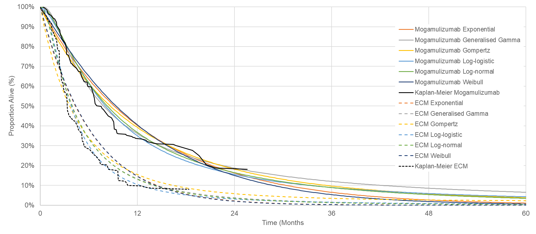
Abbreviations: NTFS, next-treatment-free survival; MF, mycosis fungoides; SS, Sezary syndrome

